How to Use GIT

Step 1. Create your account in GIT

Step 2. Create Repository on web browser example

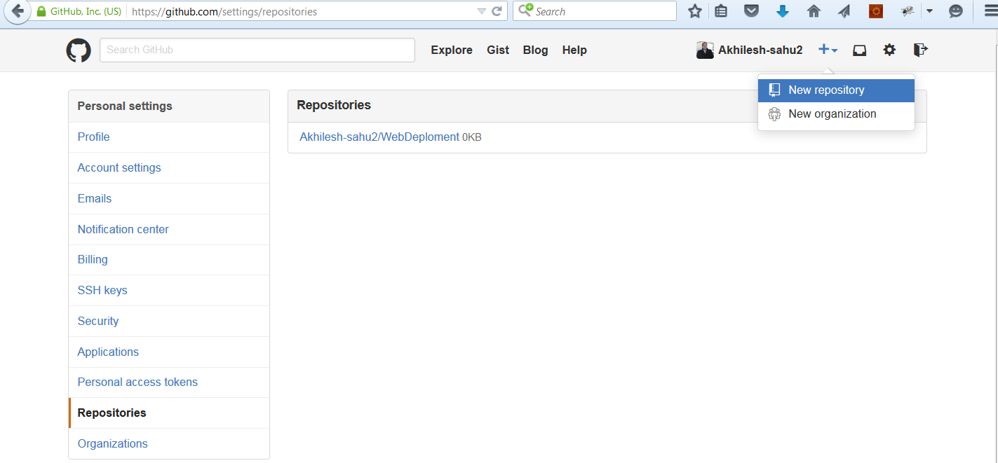

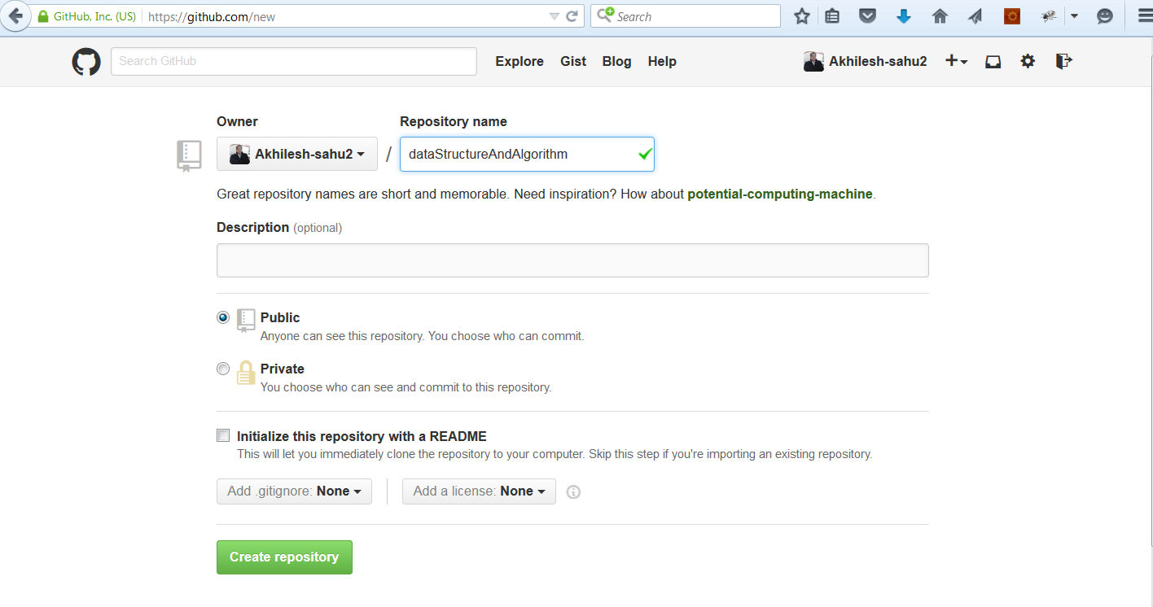

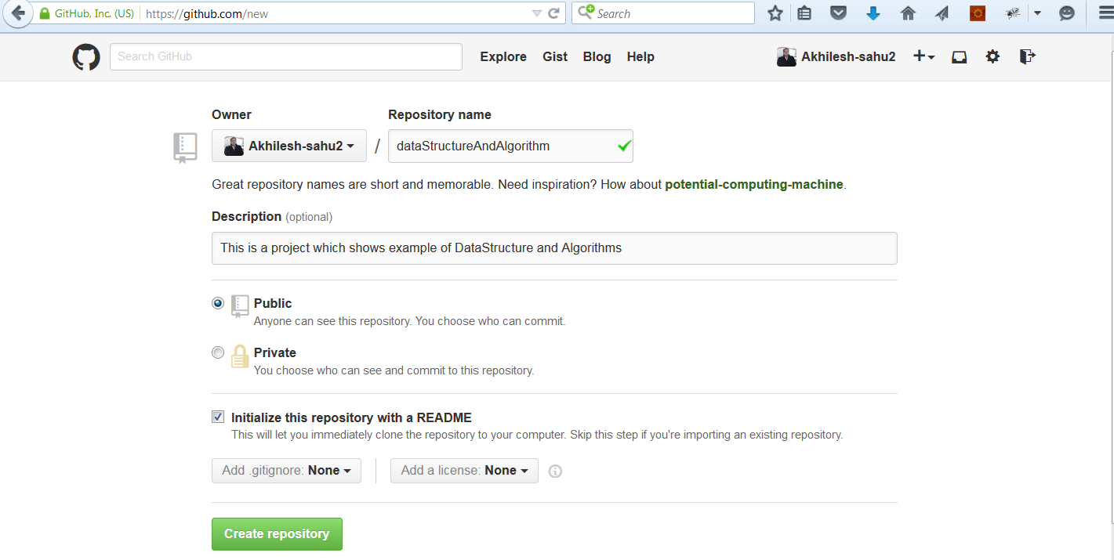

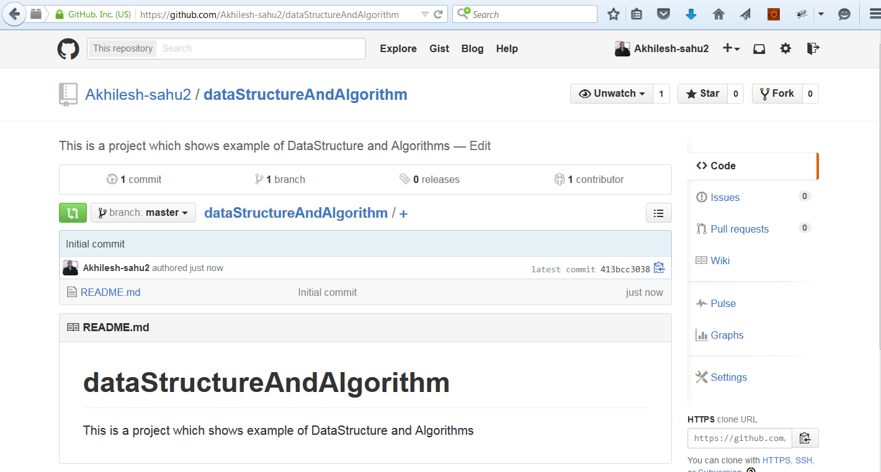

Now take the clone URL and clone it where u want to use example eclipse

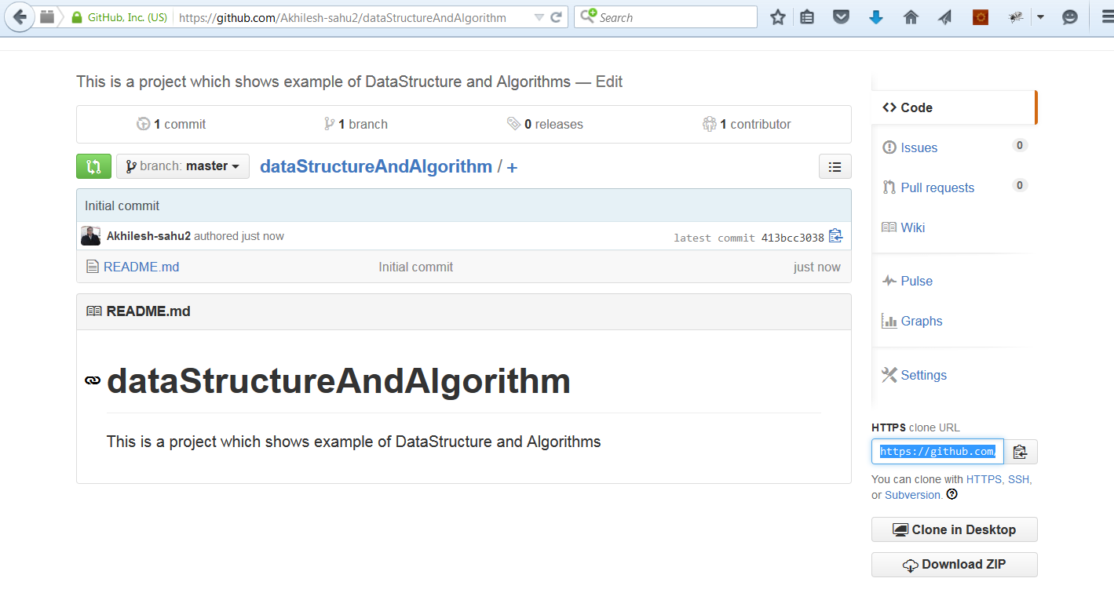

Eclipse setup

Go to marketplace and install GitHub extensions for eclipse

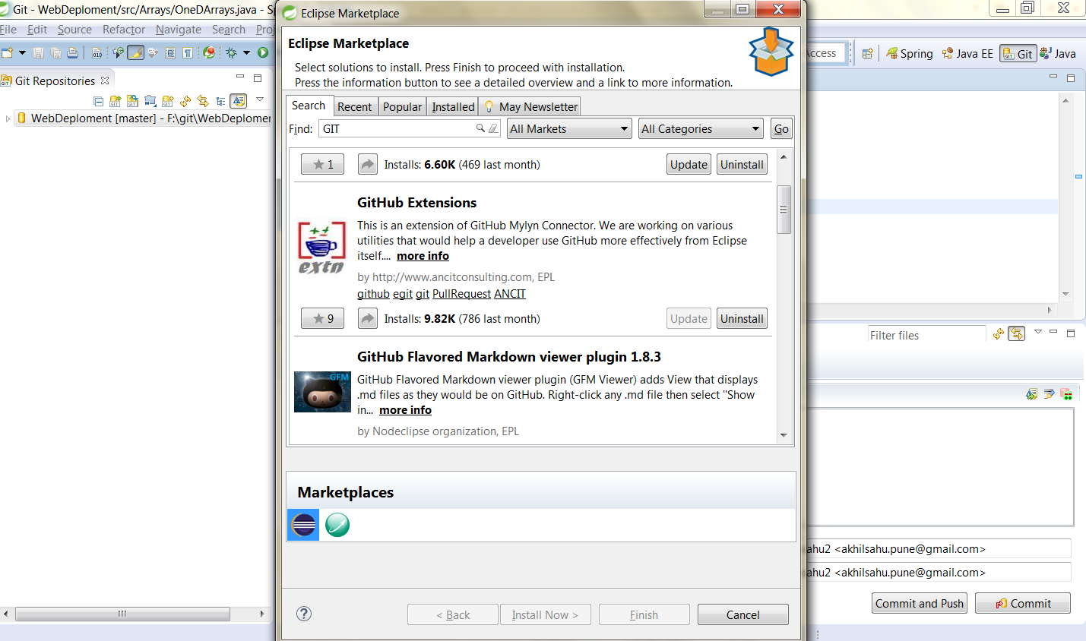

After installing it open git perspective

Clone Ur Repository Local through STS Eclipse

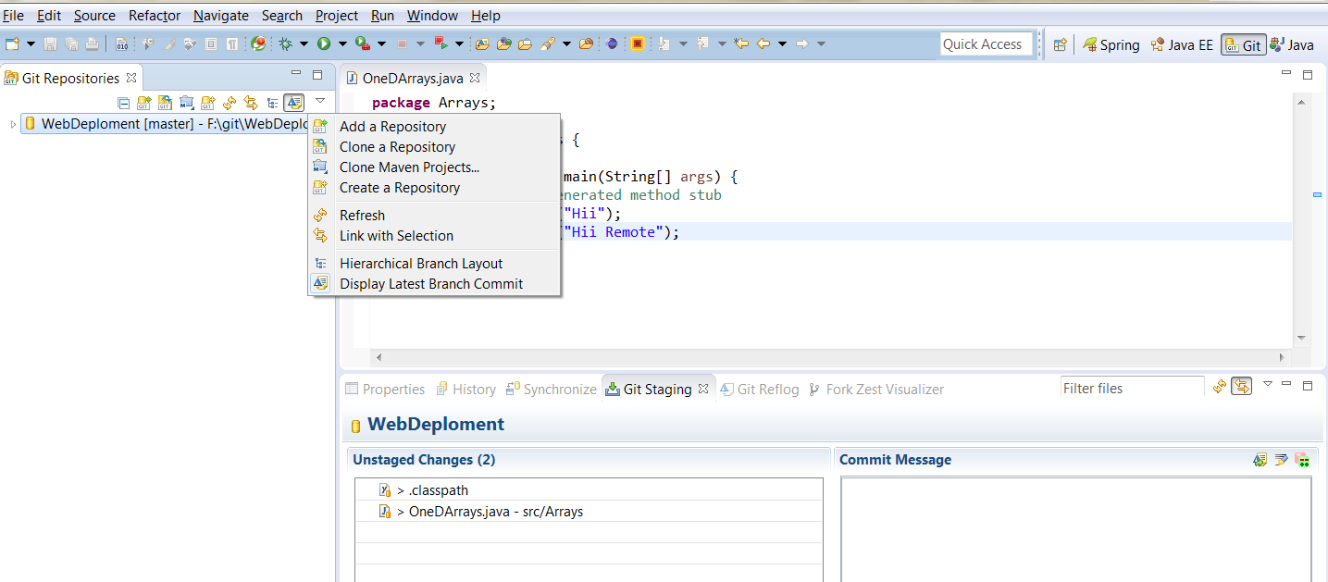

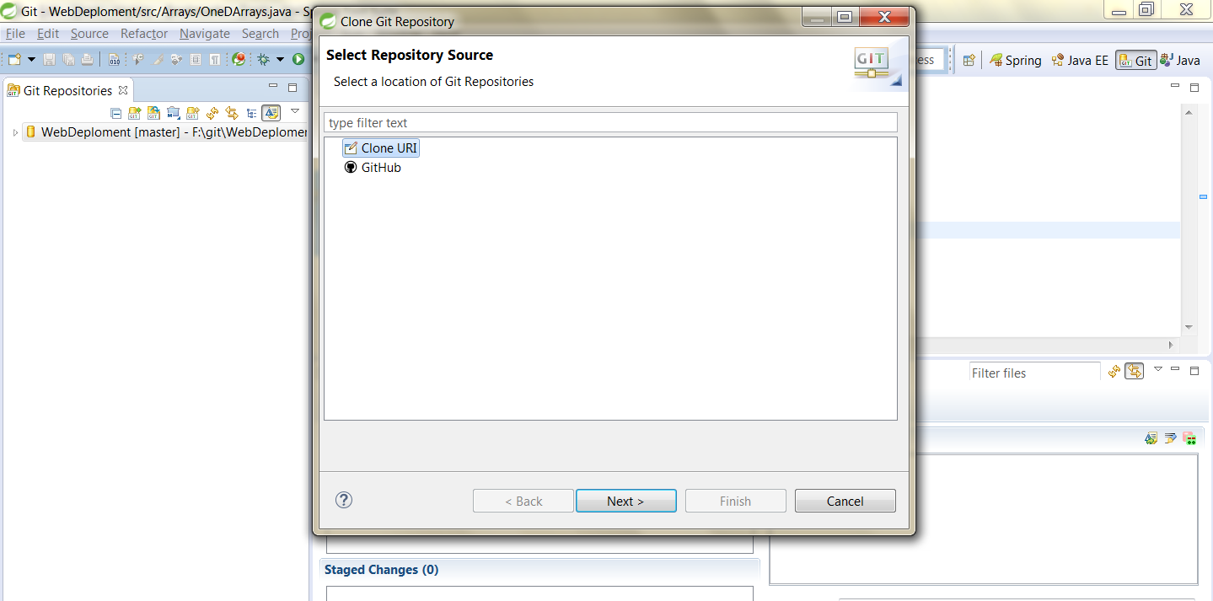

Enter ur git username/emailed and password

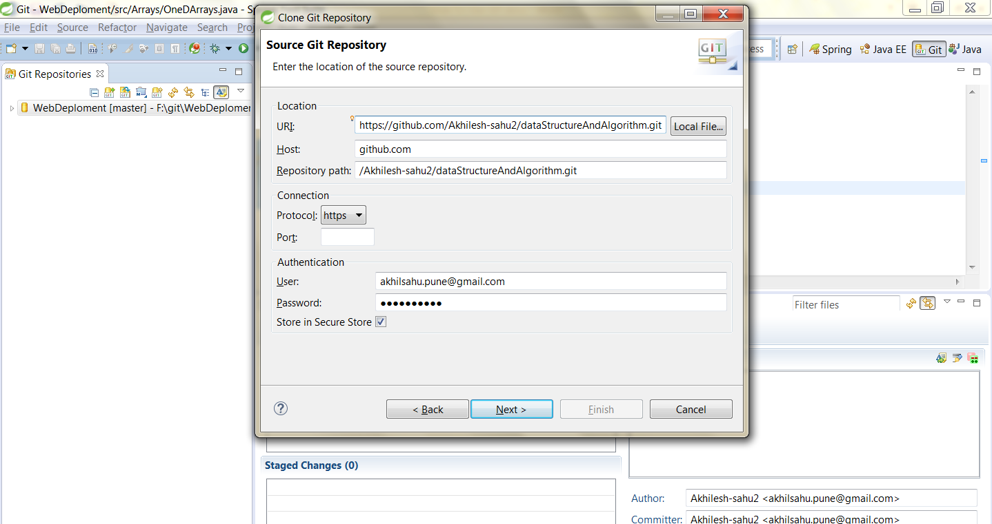

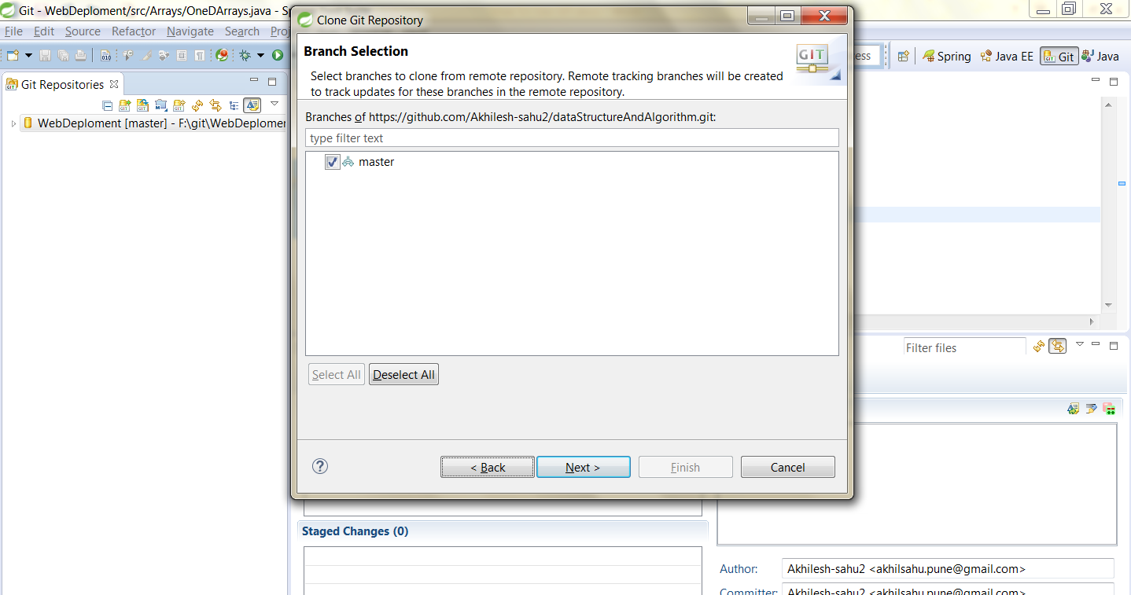

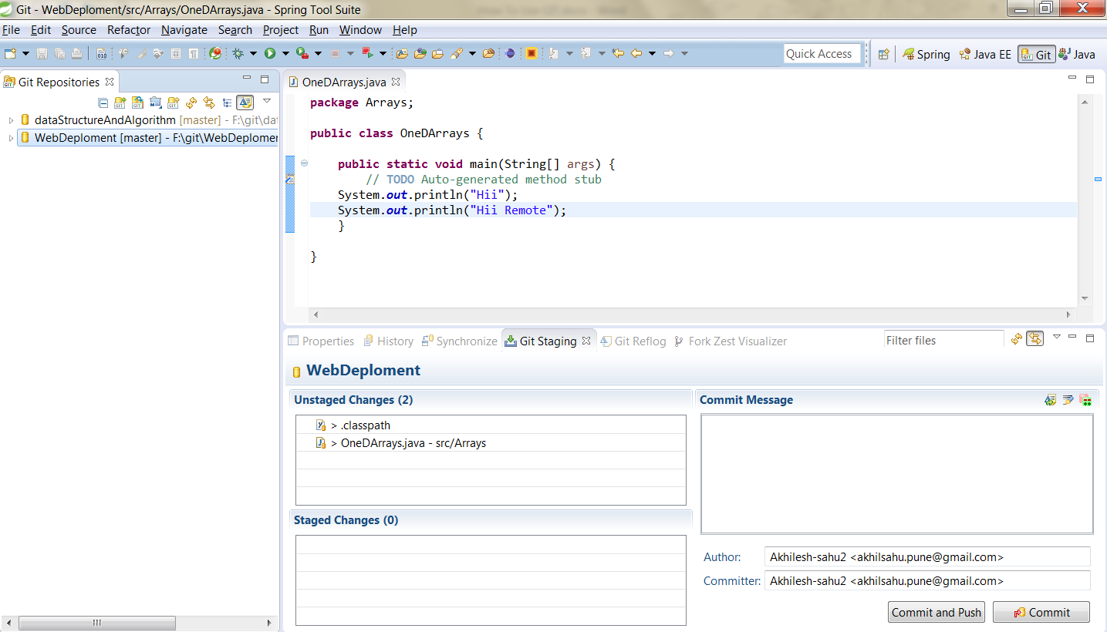

It will create a repository locally

For creating your project in repository go in project explorer and create what kind of project you want to create

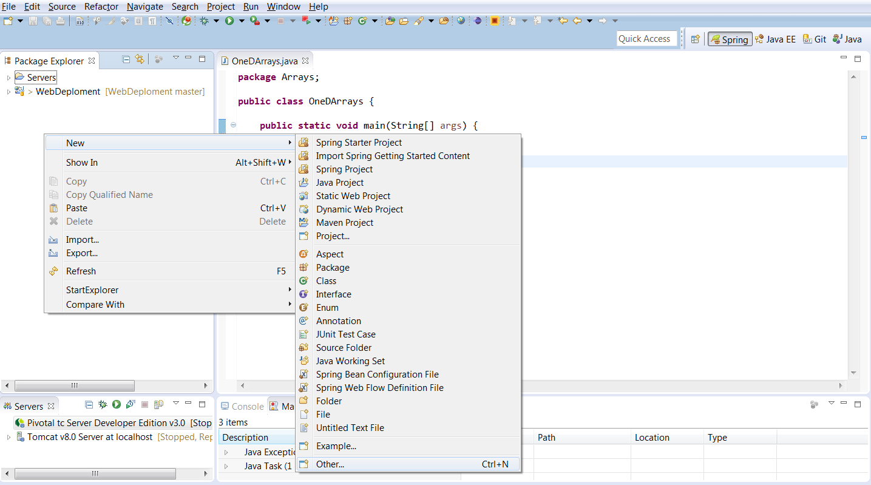

For creating project use the same path where you have cloned the repository

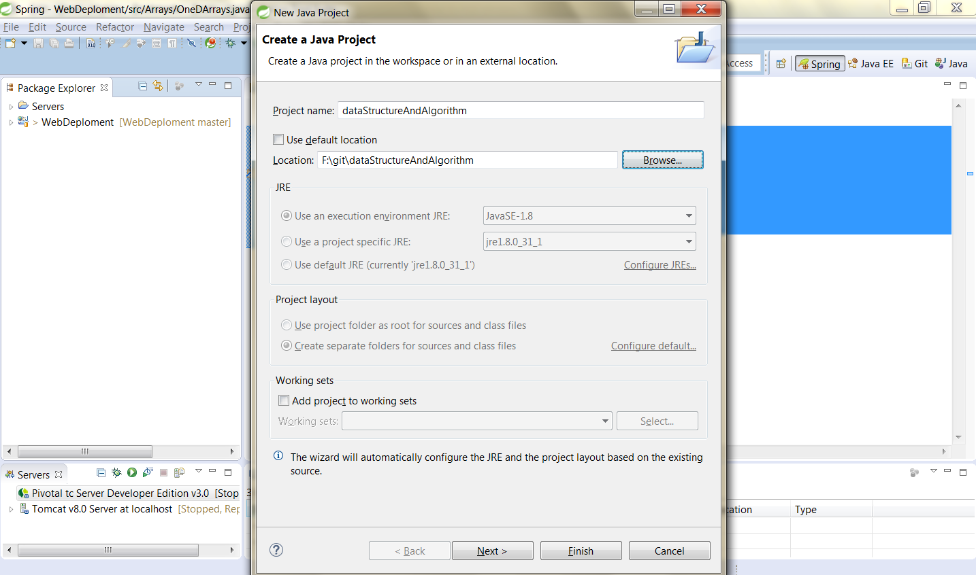

Create project with the same name as repository

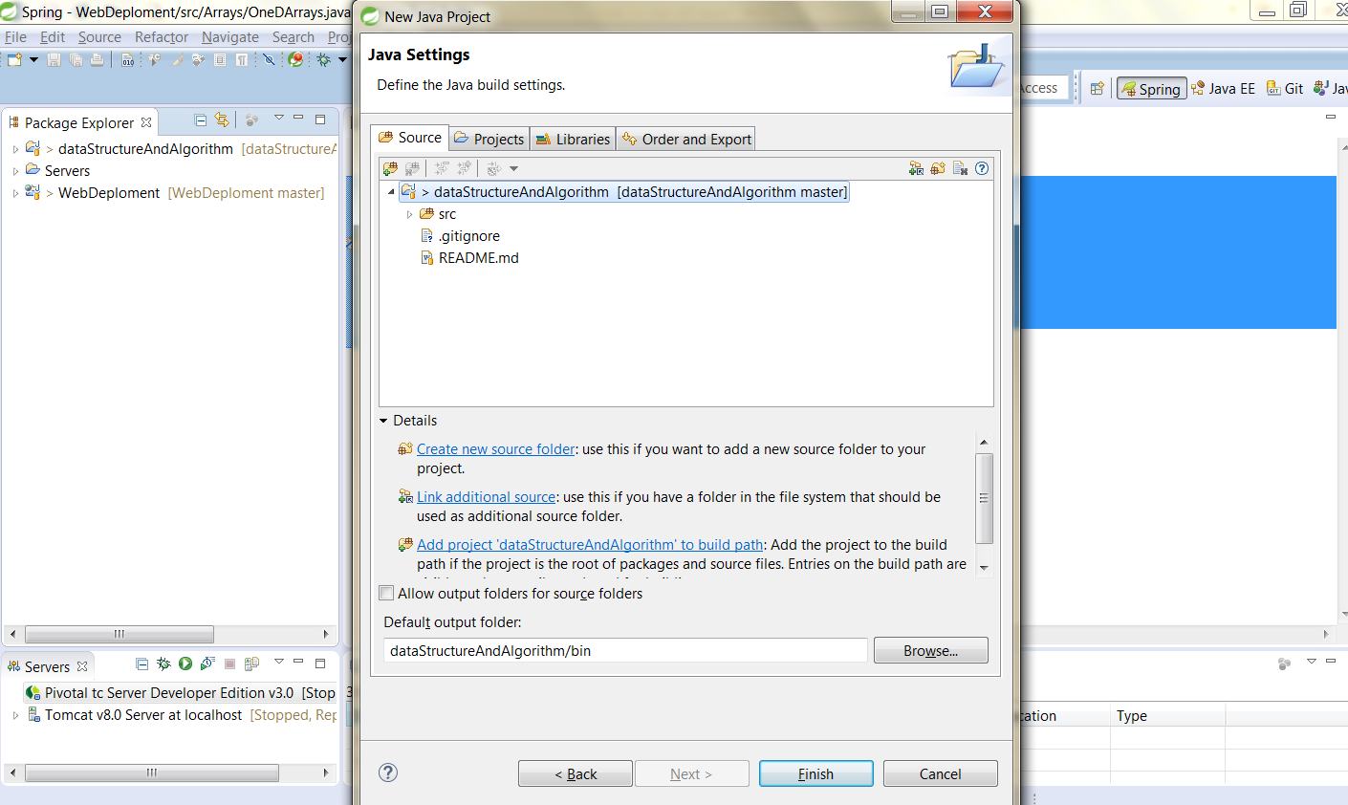

Now create your file in the project as you like

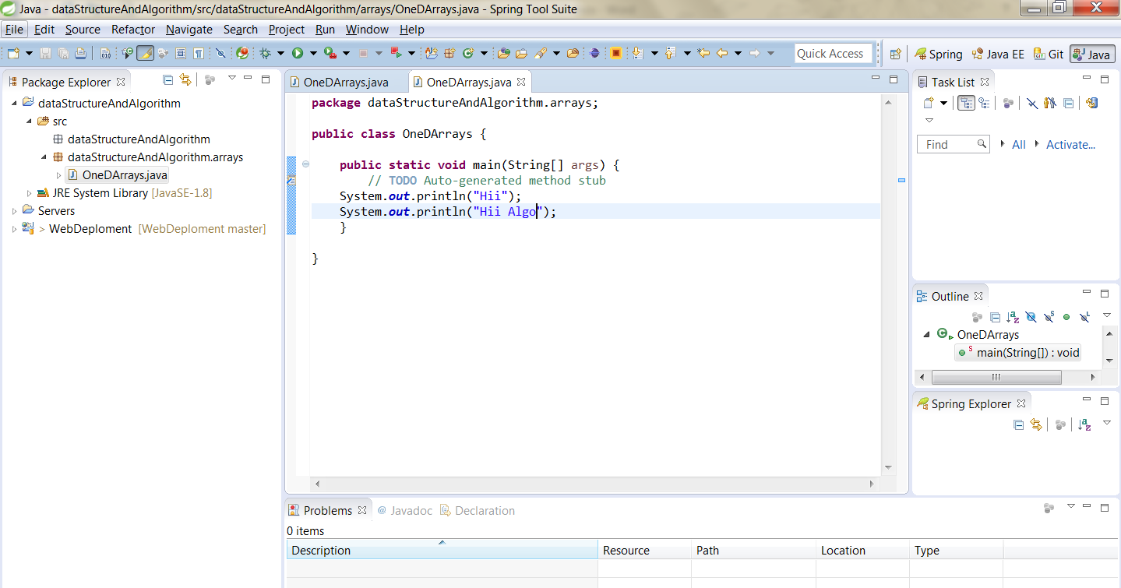

Now For committing and pushing the changes that you have made go in gitstaging and select the repository it will shows changes in the unstaged changes window.

Select which changes u want to commit and push (drag and drop in staged changes) and click oncommit and push and enter the appropriate comment in comment message box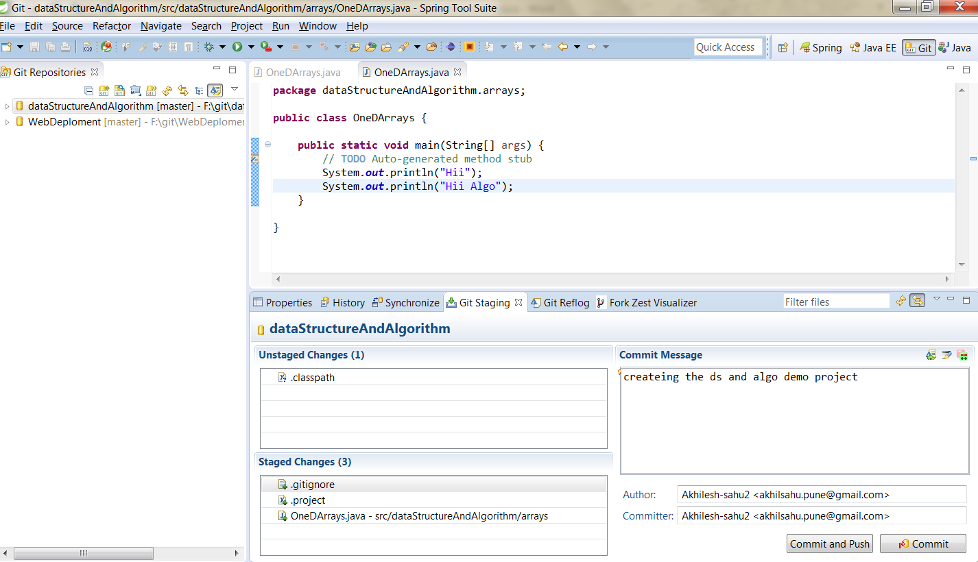

After clicking u will see the window like this

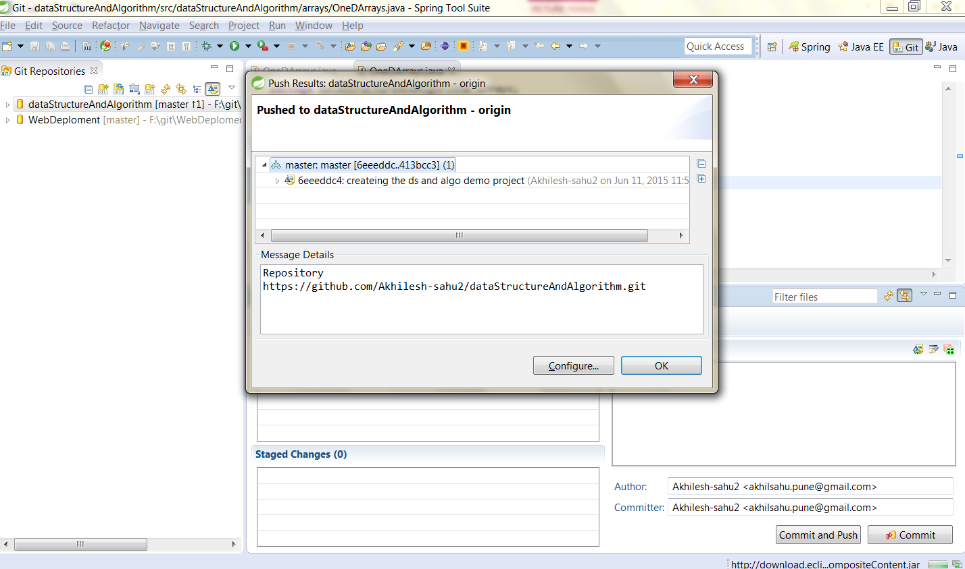

Now u have to configure the push path. Click on configure

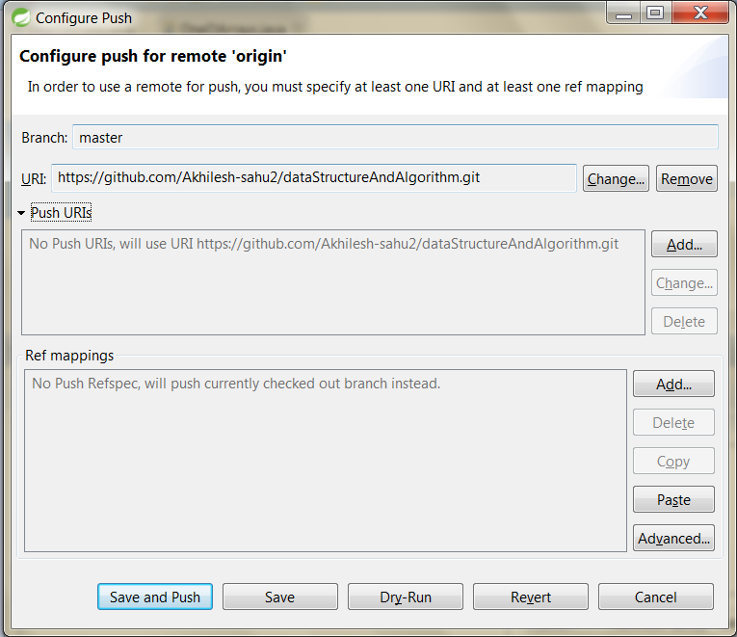

Add push url as it is as in URL box

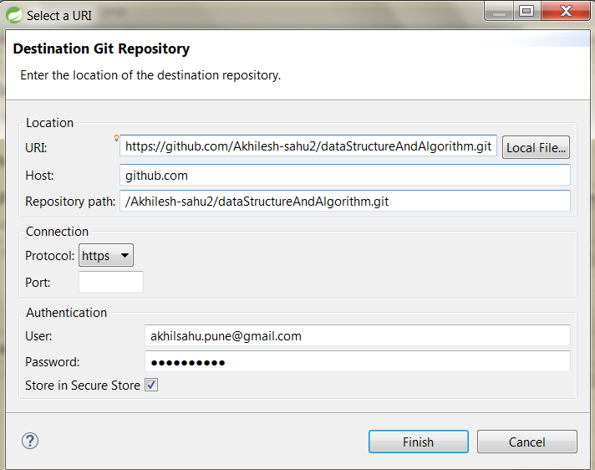

Click on finish

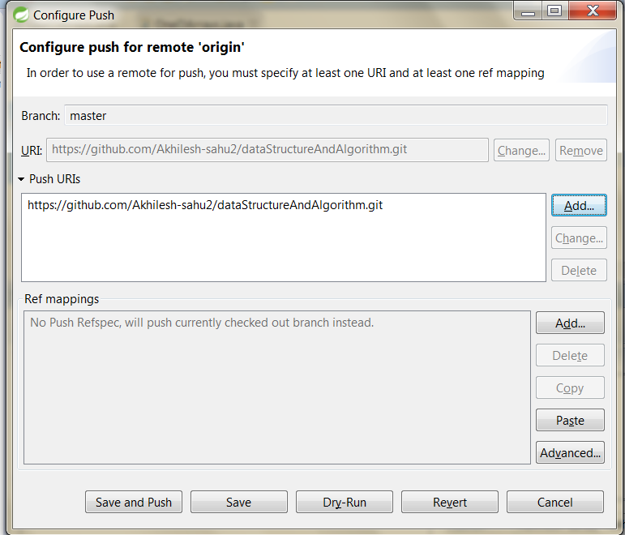

Now save and push

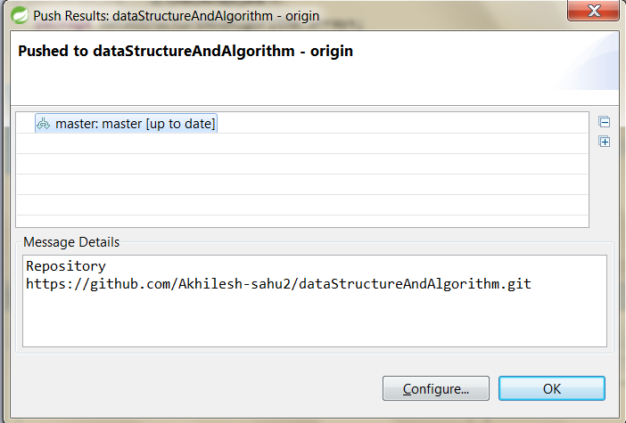

Click ok that it all

Check ur repository on git account on web

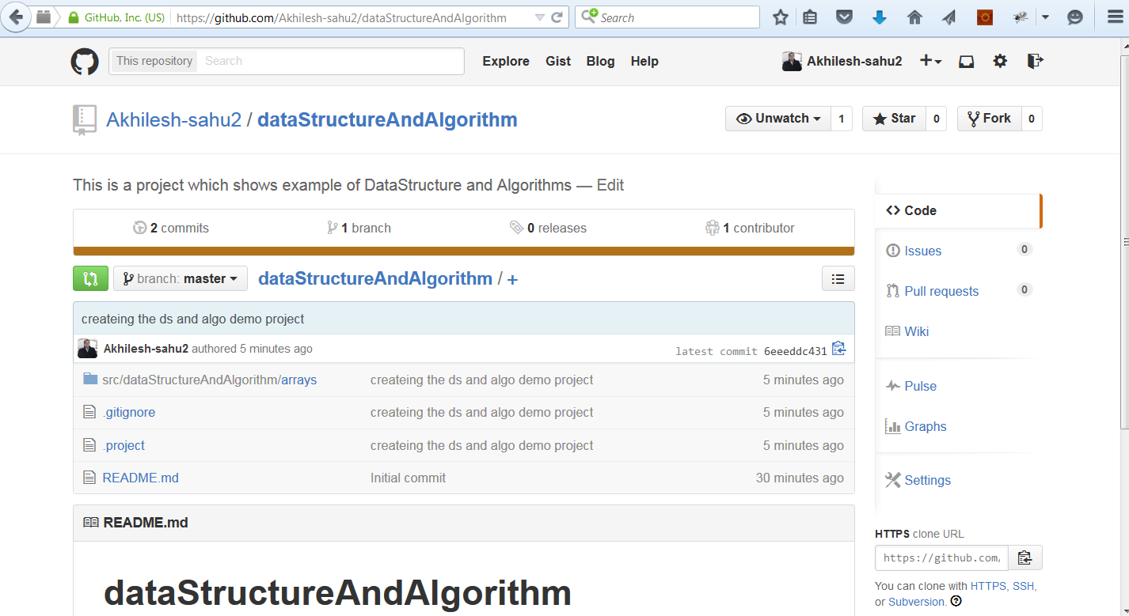

Now your Git repository is ready with your project

If you want to use this on any other place just make a clone repository with clone URL

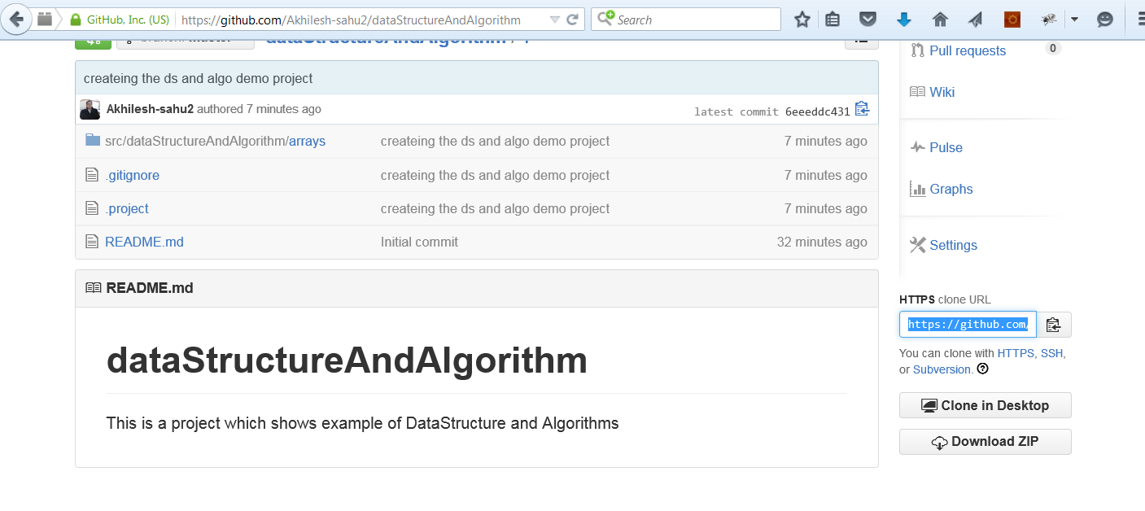

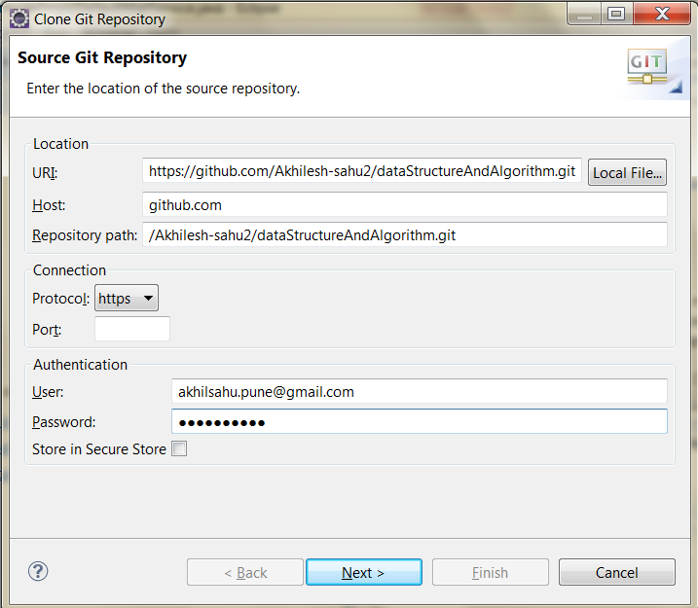

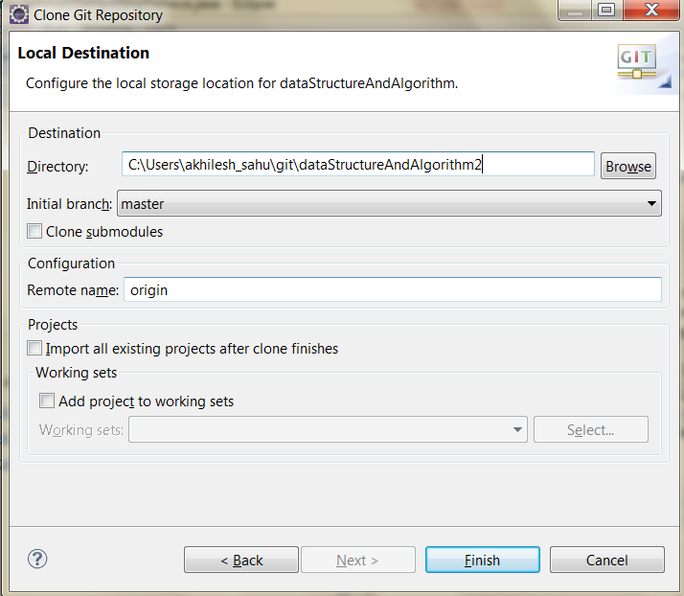

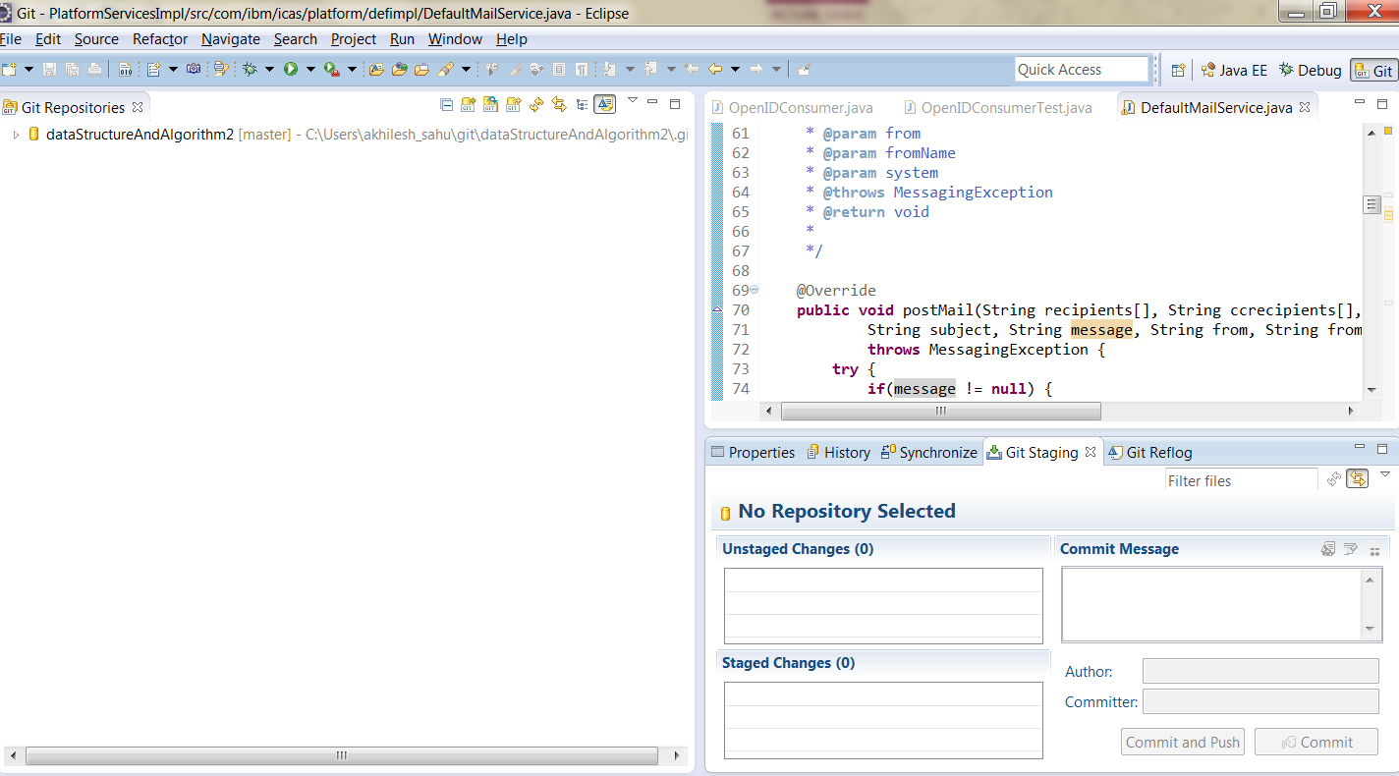

Creaing project in ur working set select Working directory 🡪 import project

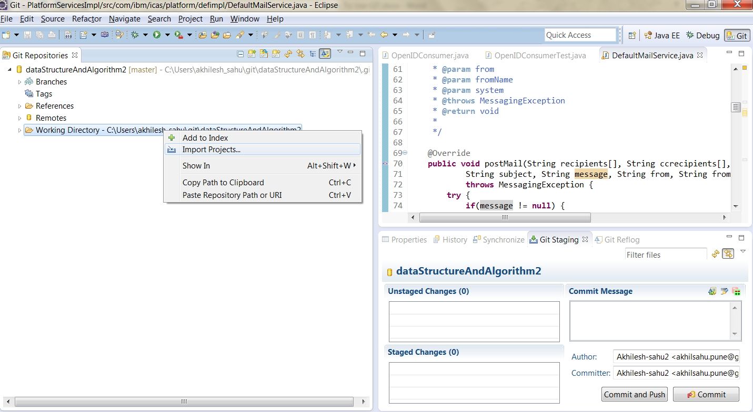

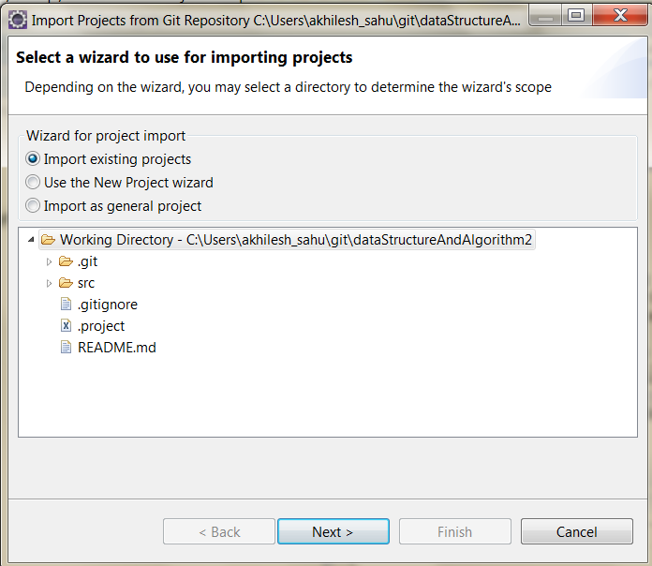

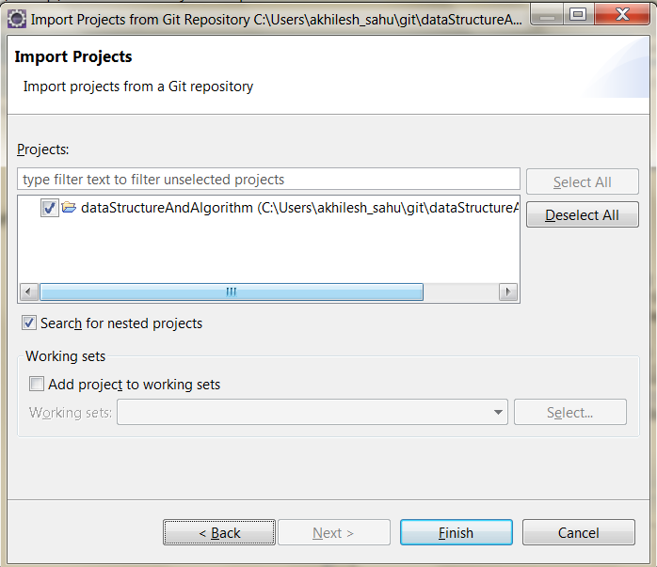

Click finish and you are able to see project in your explorer (Project explorer)

All done for work from multiple pupal